**EXP NO** : 10 **DATA VISUALIZATION USING TABLEAU**

**DATE** : 30/10/2023

**AIM :**

To implement pictorial and graphical representation of data using Tableau.

**PROCEDURE :**

1. Installing Tableau on your System
2. Import the Data into tableau workspace from the computer.
3. Under the Sheets Tab, three sheets will become visible namely Orders, People, and Returns. However, we will focus only on Orders data. Double click on Orders Sheet, and it opens up just like a spreadsheet.
4. Creating a View.
5. Refining the View.
6. Emphasizing the Results.
7. Map View.
8. Key Findings.
9. Making a Conclusion.

**CONCEPT APPLIED :**

Tableau is a data analytics and visualization tool. It’s the leading (33% market share followed by Power-BI) data analytics and visualization tool in the market. Tableau comes with a very easy drag-drop interface which makes it easy to learn and you can work on almost every type of data in Tableau.

This makes it an excellent choice for data analysts.

**OUTPUT :**

**Bar chart:**

Horizontal bars can be created by selecting that type of chart from Show Me menu on right hand side ofCanvas. The type of chart in box on right hand side represents horizontal bar graph.

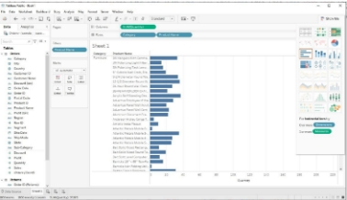

**stacked bar graph:**

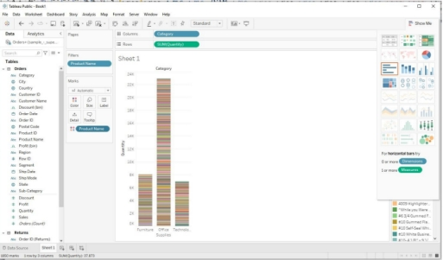

**Side-by-side bar chart :**

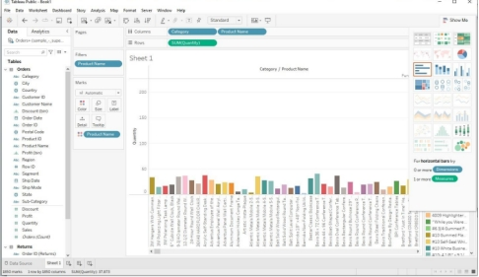

**Line graph: Line graph can be continuous or discrete.**

**Continuous line graph is shown below:**

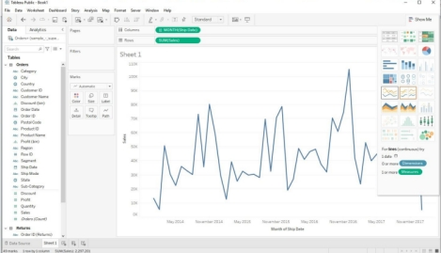

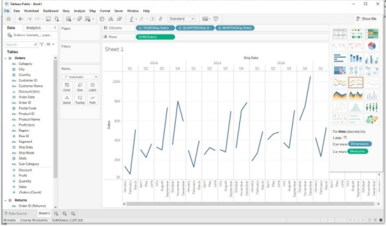

**Pie chart:**

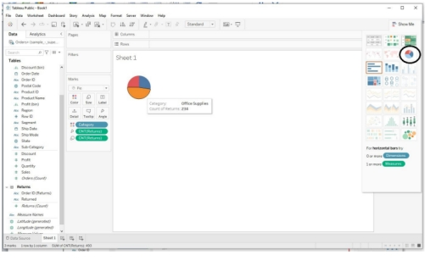

**Bubble chart:**

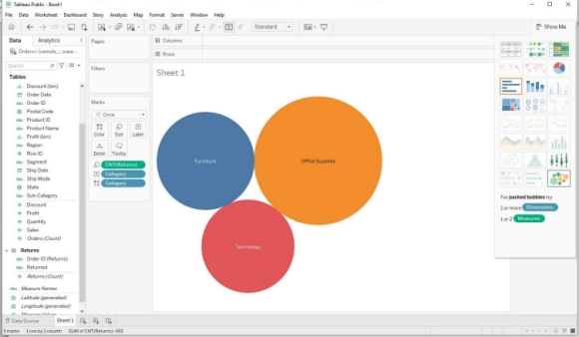

**Heat map:**

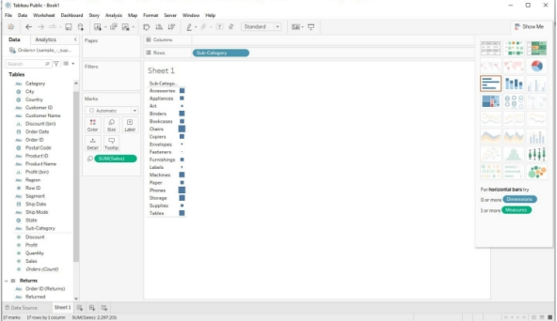

**RESULT :**

Thus, the Data visualization was implemented by using tableau.